Exela Full Stack Developer Hiring Challenge

**Challenge:** Electricity Bill CRUD

**Problem statement:** Develop a full stack web application which would let users enter their electricity bills data and thus can view that information and operate them.

**Source Code Repositories**

1. electricity-bill-api
2. electricity-bill-ui

**ELECTRICITY-BILL-API**

* Python, FastAPI
* SqlAlchemy

**API**

1. Bills
   1. Get all bills - GET [http://127.0.0.1:8000/api/v1/bill/](http://127.0.0.1:8000/api/v1/reminder/)
   2. Create bill - POST [http://127.0.0.1:8000/api/v1/bill/](http://127.0.0.1:8000/api/v1/reminder/)
   3. Get bill - GET [http://127.0.0.1:8000/api/v1/bill/{id}/](http://127.0.0.1:8000/api/v1/reminder/)
   4. Update bill - POST [http://127.0.0.1:8000/api/v1/bill/{id}/](http://127.0.0.1:8000/api/v1/reminder/)
   5. Delete bill - DELETE [http://127.0.0.1:8000/api/v1/bill/{id}/](http://127.0.0.1:8000/api/v1/reminder/)
2. Users
   1. Get all users - GET [http://127.0.0.1:8000/api/v1/user/](http://127.0.0.1:8000/api/v1/reminder/)
   2. Create user - POST [http://127.0.0.1:8000/api/v1/user/](http://127.0.0.1:8000/api/v1/reminder/)
   3. Get user - GET [http://127.0.0.1:8000/api/v1/user/{id}/](http://127.0.0.1:8000/api/v1/reminder/)
   4. Update user - POST [http://127.0.0.1:8000/api/v1/user/{id}/](http://127.0.0.1:8000/api/v1/reminder/)
   5. Delete user - DELETE [http://127.0.0.1:8000/api/v1/user/{id}/](http://127.0.0.1:8000/api/v1/reminder/)
   6. Get user bills - [http://127.0.0.1:8000/api/v1/user/{id}/bills/](http://127.0.0.1:8000/api/v1/reminder/)

**GUIDE**

1. Package dependencies
   1. pipenv - **pip3 install pipenv** & **pipenv shell**
   2. fastapi - **pip3 install fastapi**
   3. uvicorn - **pip3 install uvicorn**
   4. fastapi-utils - **pip3 install fastapi-utils**
   5. sqlalchemy - **pip3 install sqlalchemy**
   6. sendgrid - **pip3 install sendgrid** - Taking time to verify the account
   7. twilio - **pip3 install twilio** - Invalid mobile number
2. Run the application
   1. Command - **uvicron main:app --reload** (runs with default port 8000)
   2. [http://127.0.0.1:8000/docs#/](http://127.0.0.1:8000/docs%23/), to see the application api routes

**ELECTRICITY-BILL-UI**

* Angular, Typescript
* Python FastAPI integration

**GUIDE**

1. Install the packages - **npm install**
2. Run the application - **npm start** (runs with default port 4200, <http://localhost:4200/>)

**USAGE**

1. Go to <http://localhost:4200/>
2. Select any user (If no user exits, Please create a new user from backend application swagger doc [http://127.0.0.1:8000/docs#/](http://127.0.0.1:8000/docs%23/).
3. Current user bills will get listed below
4. Enables option to create bill
5. Create bill
   1. Select Bill created on and paid on dates.
   2. Enter units consumed and amount paid.
   3. Select house type. (Can be used in future to implement house type based per unit cost and more)
   4. Validations incorporated accordingly.
   5. Click create bill button, basically hits the “Create Bill” API in backend.
6. Once a bill is created, “Create Bill Form” will get disabled and a new bill will get added to the bills list.
7. Pagination enabled with default 10 items per page (it can be customisable).
8. Bill record options
   1. VIEW
   2. EDIT
   3. DELETE
9. Sorting data - column AMOUNT
   1. Click on Amount column to sort the data based on amount values in order Ascending or Descending.

APPLICATION FLOW SCREENSHOTS

*Backend API Swagger UI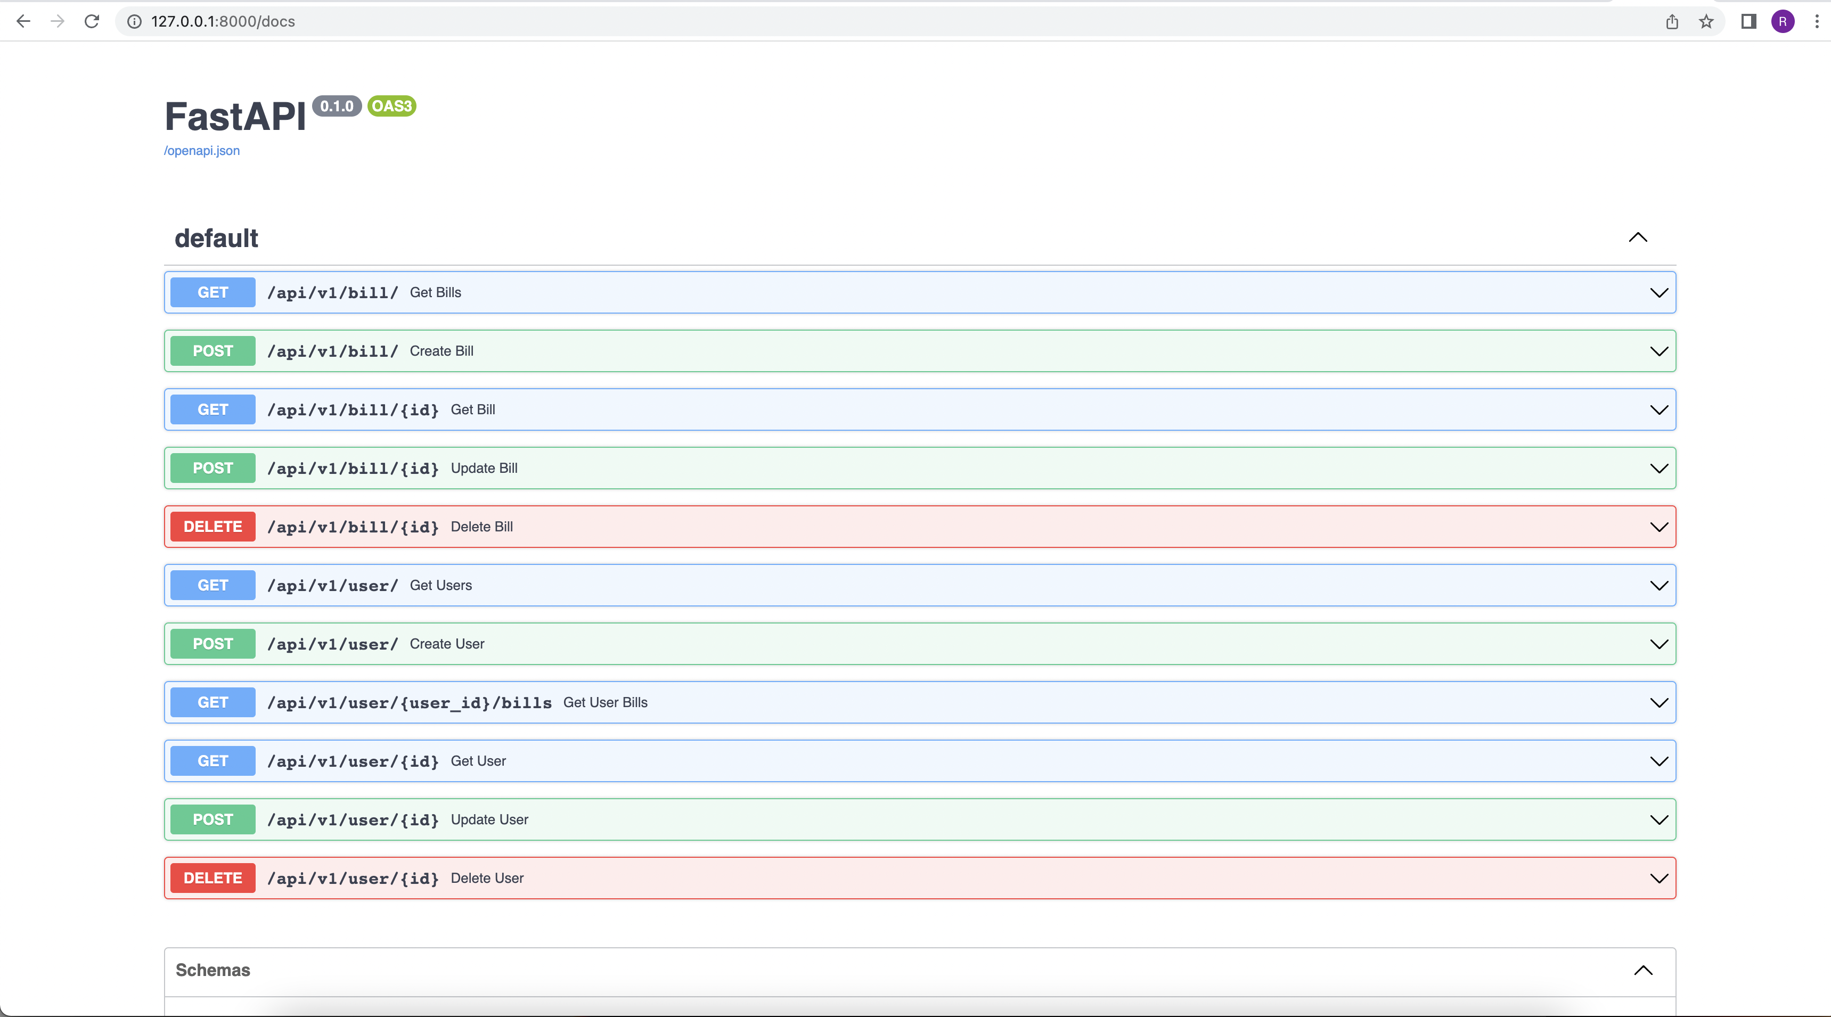*

*Create User API execution (BACKEND)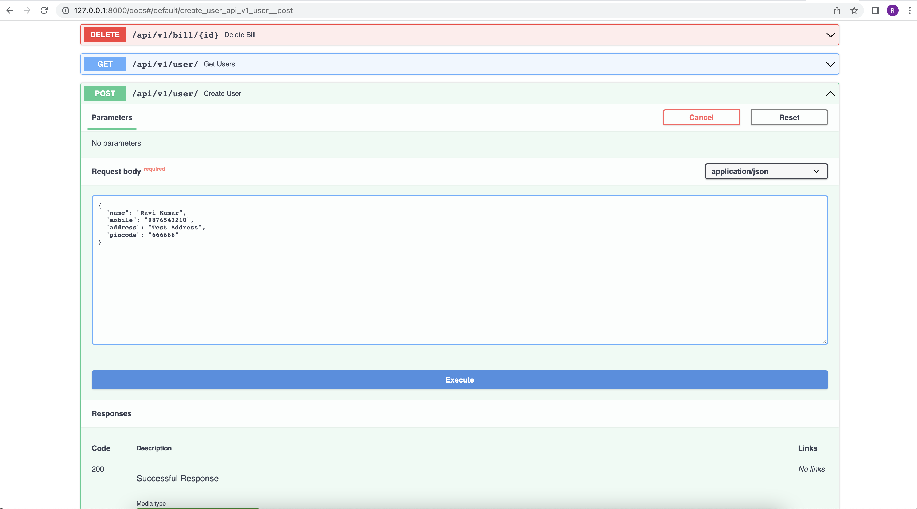*

*UI Application Home Page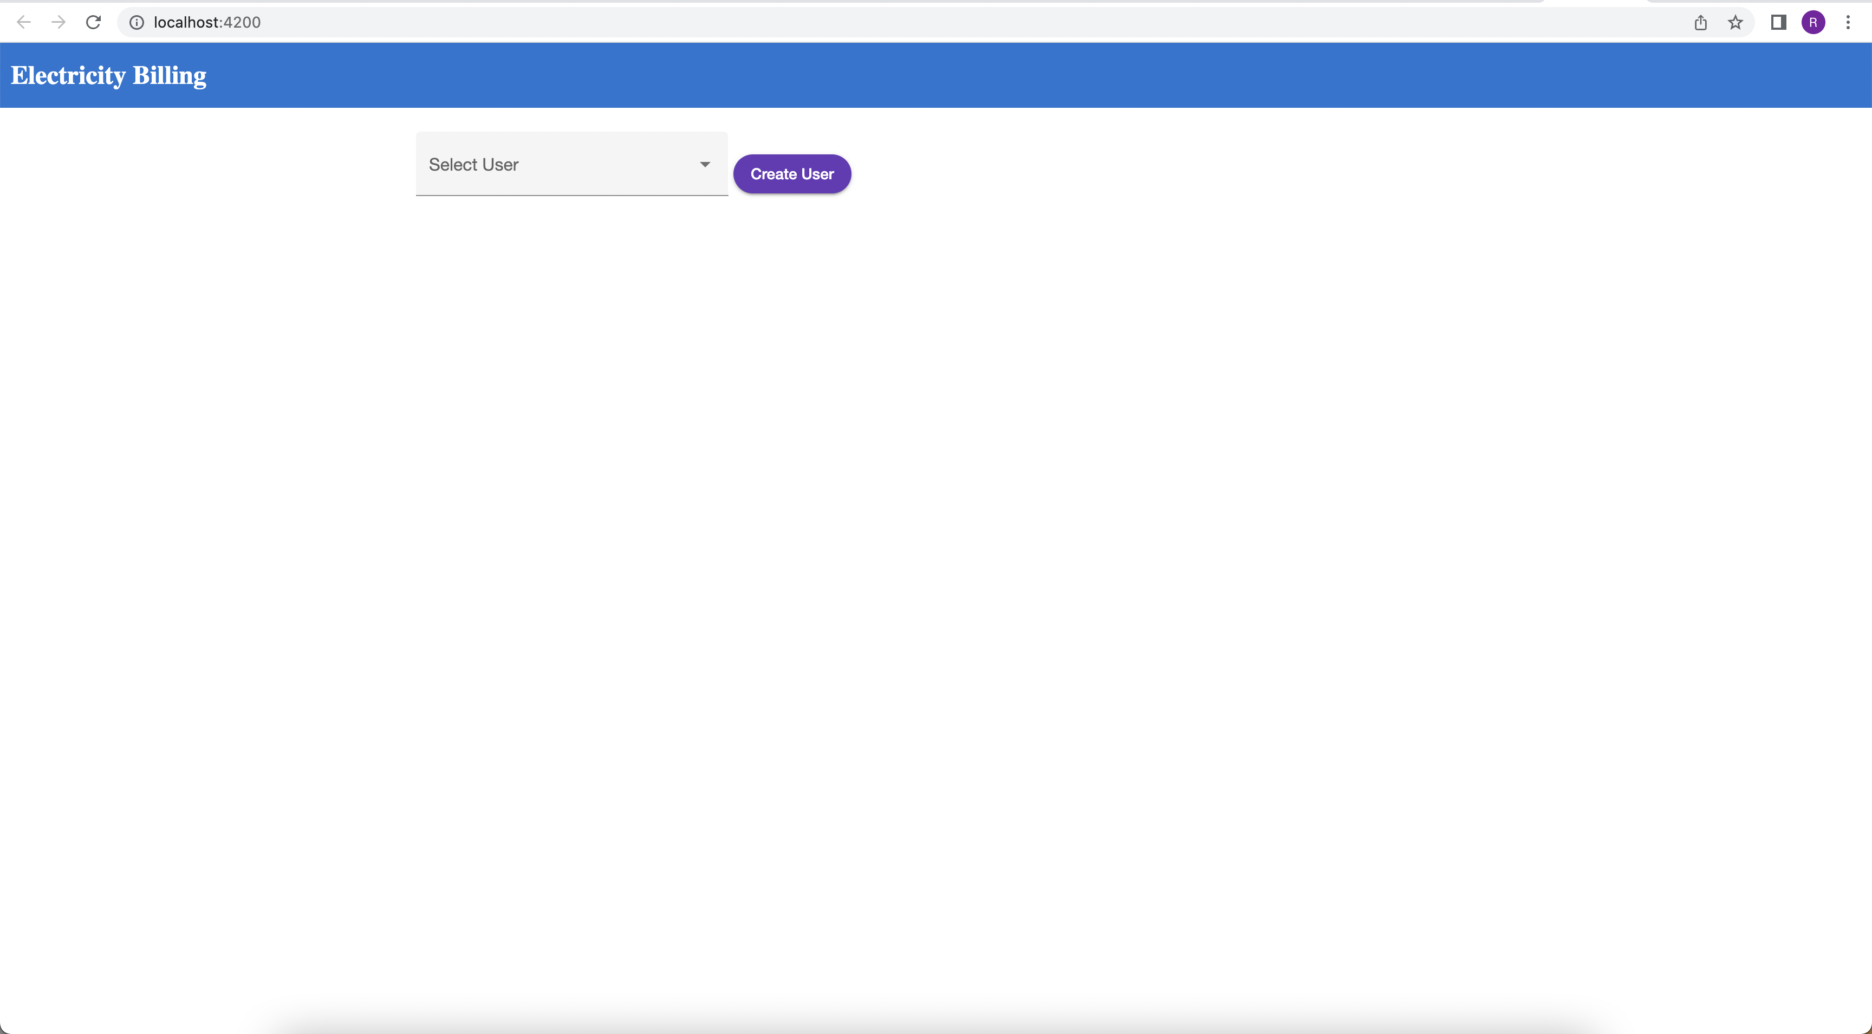*

*Create User API execution (FRONTEND)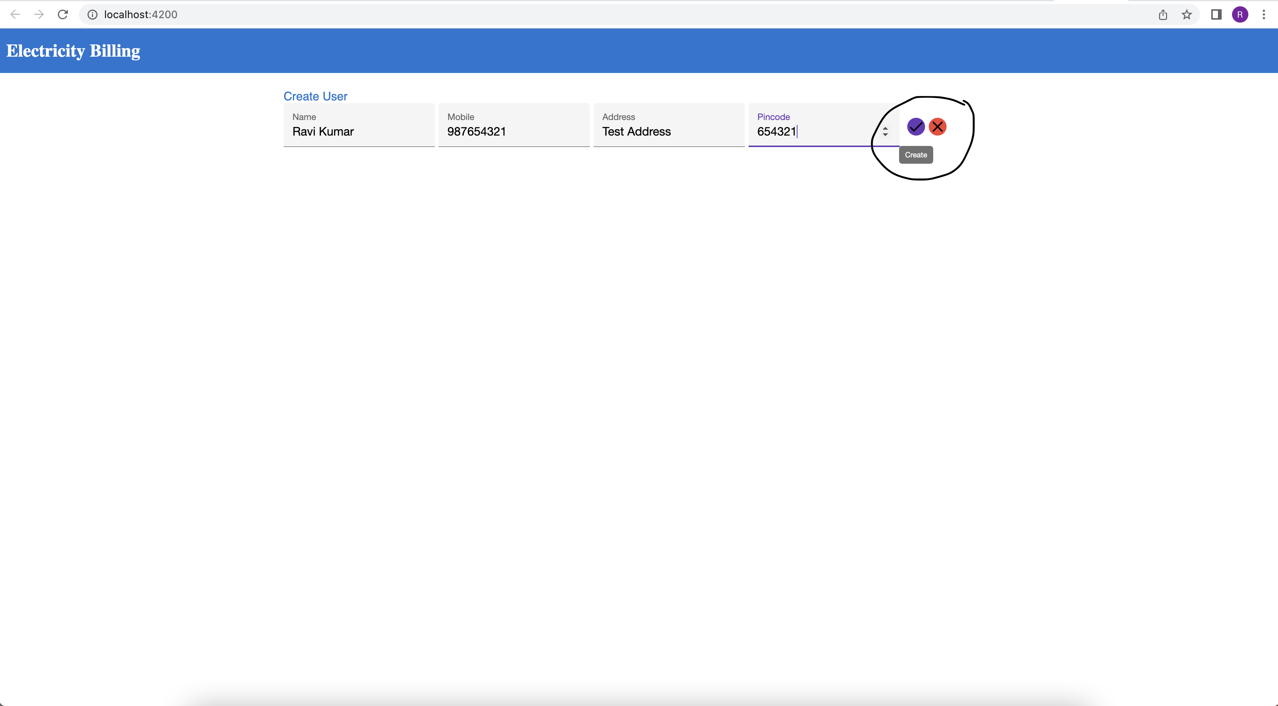*

*Select any User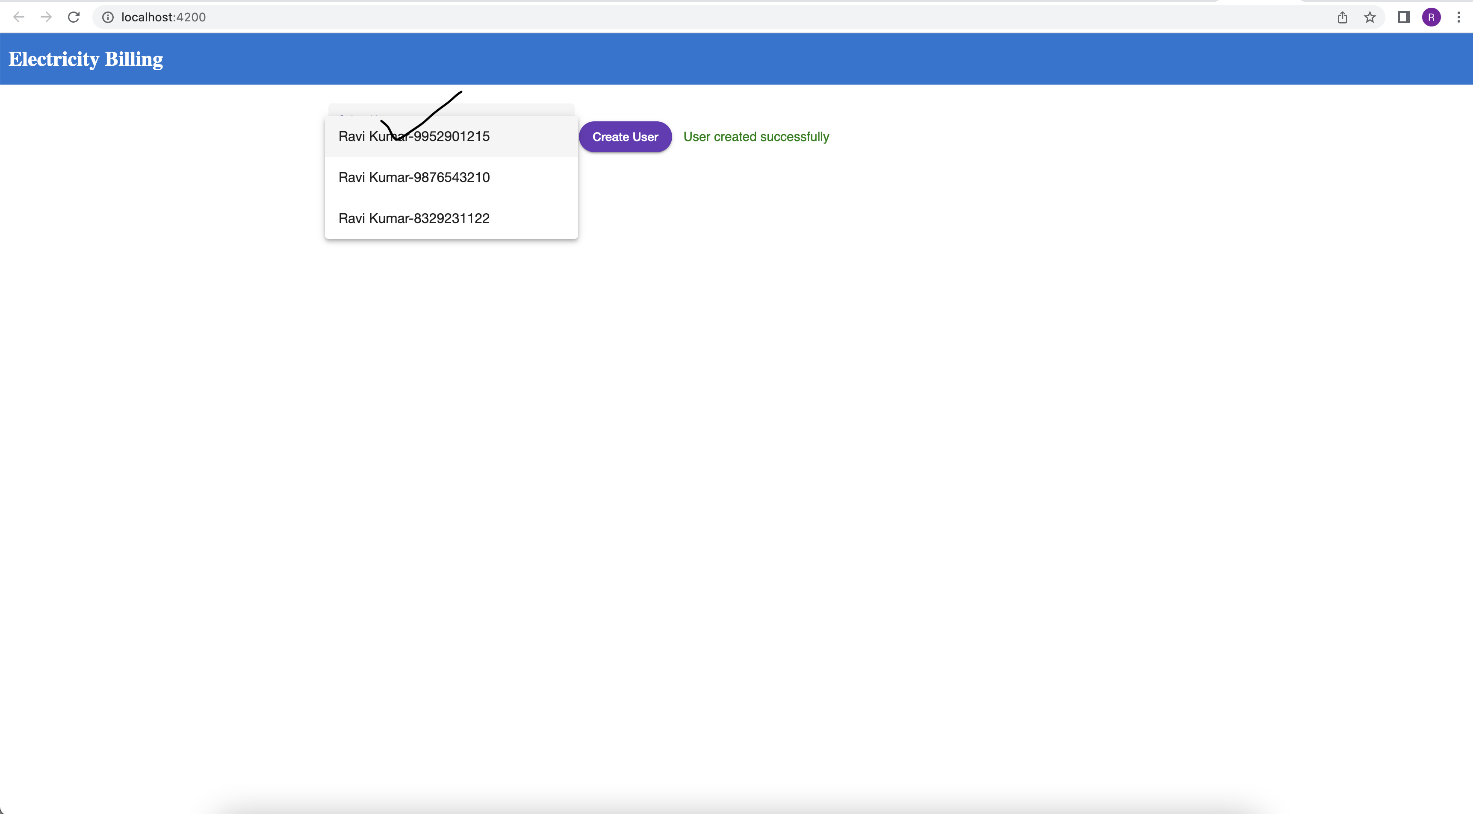*

*View all the User Bills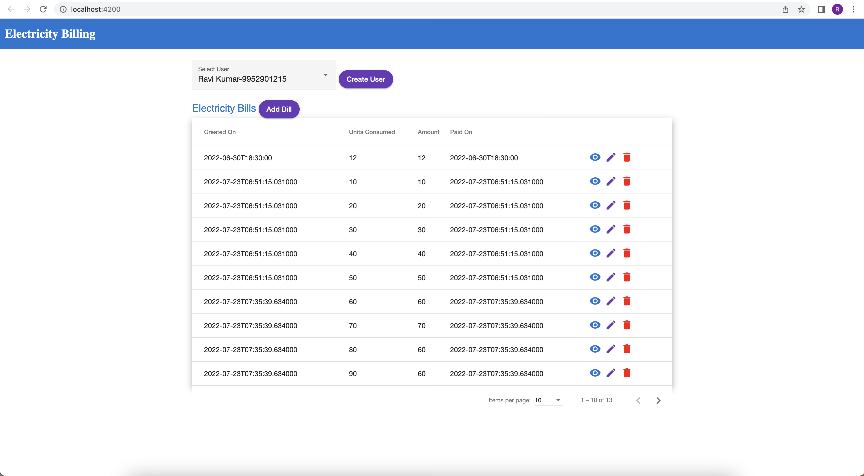*

*Click on Create Bill, Enter the Bill Details & Create Bill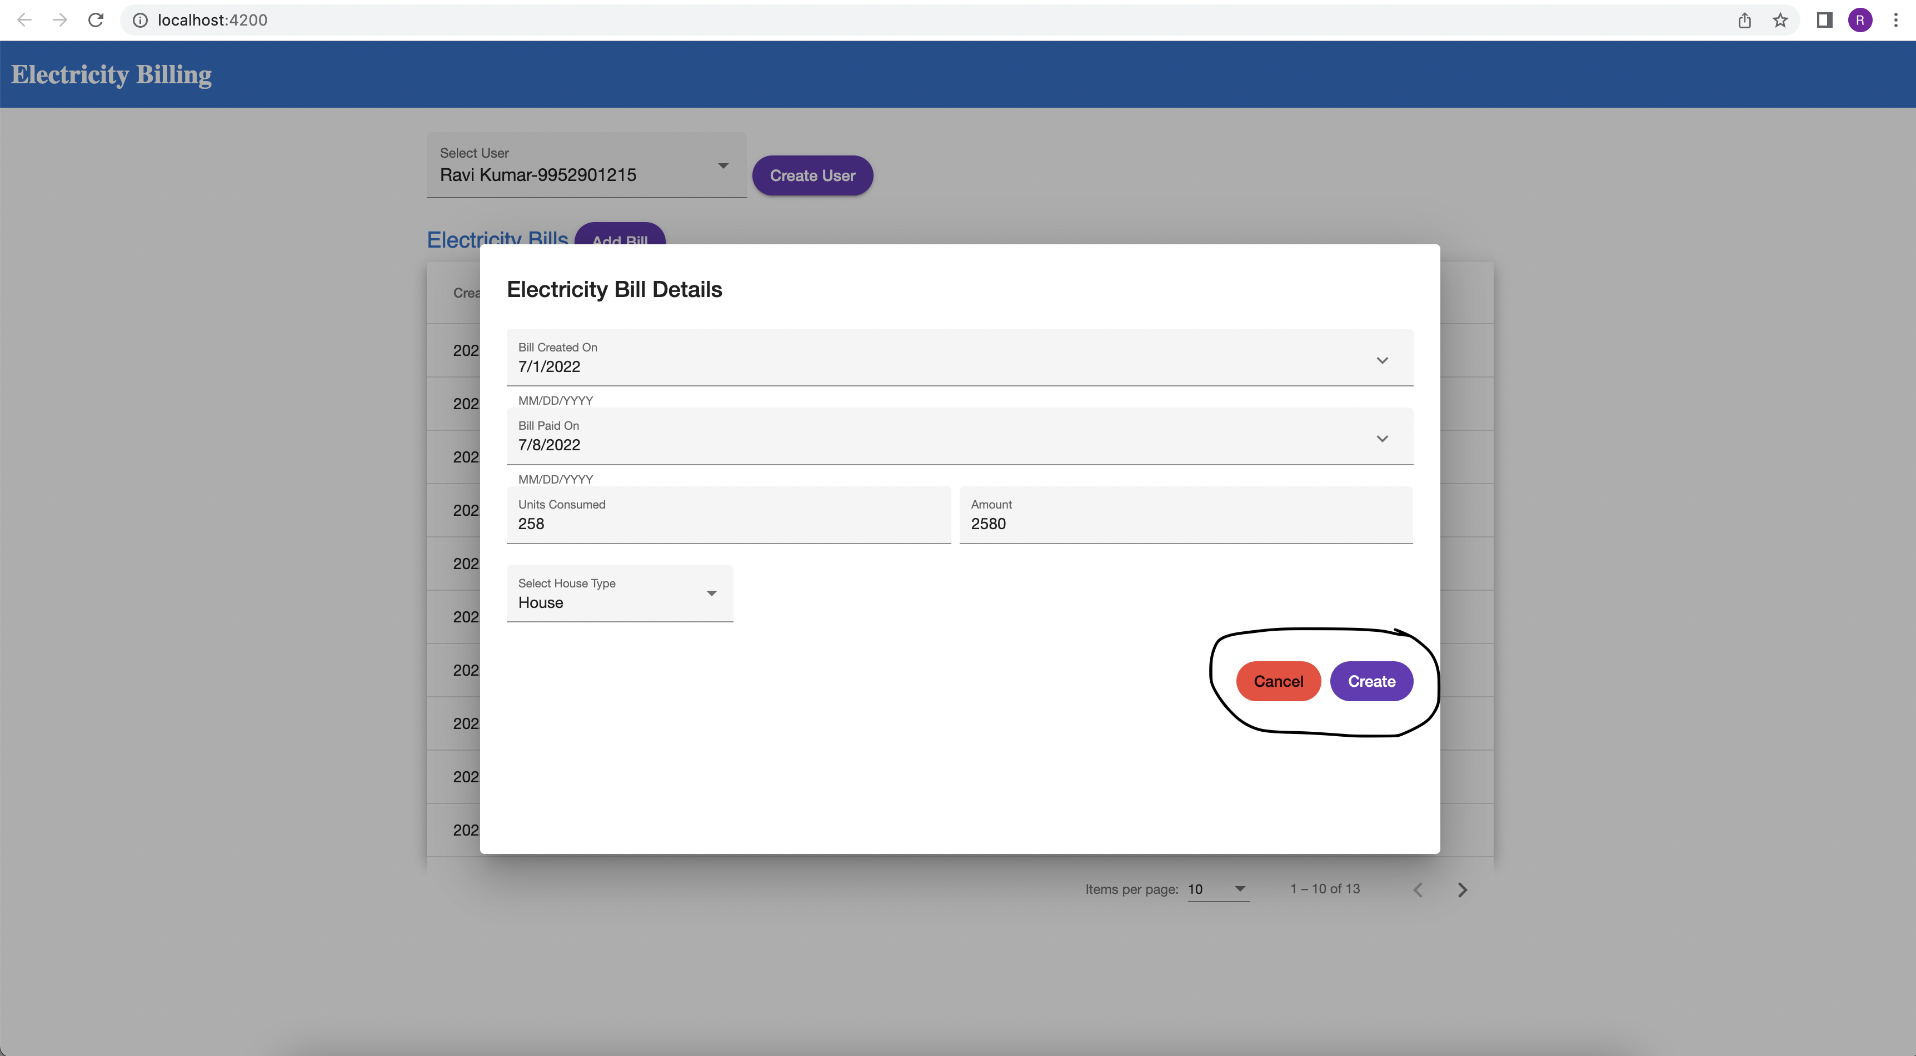*

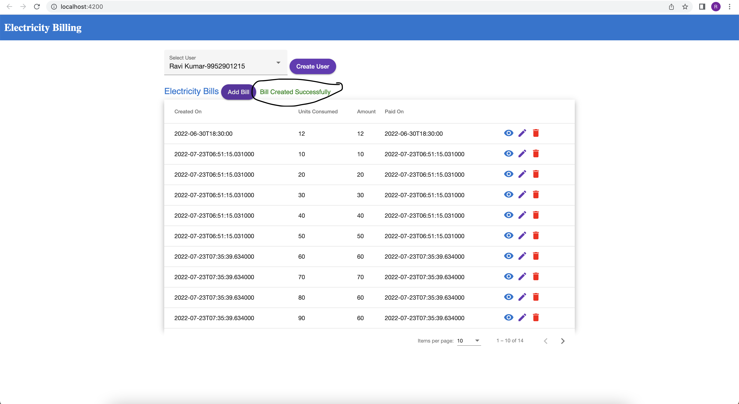

*View & Edit any Bill and Delete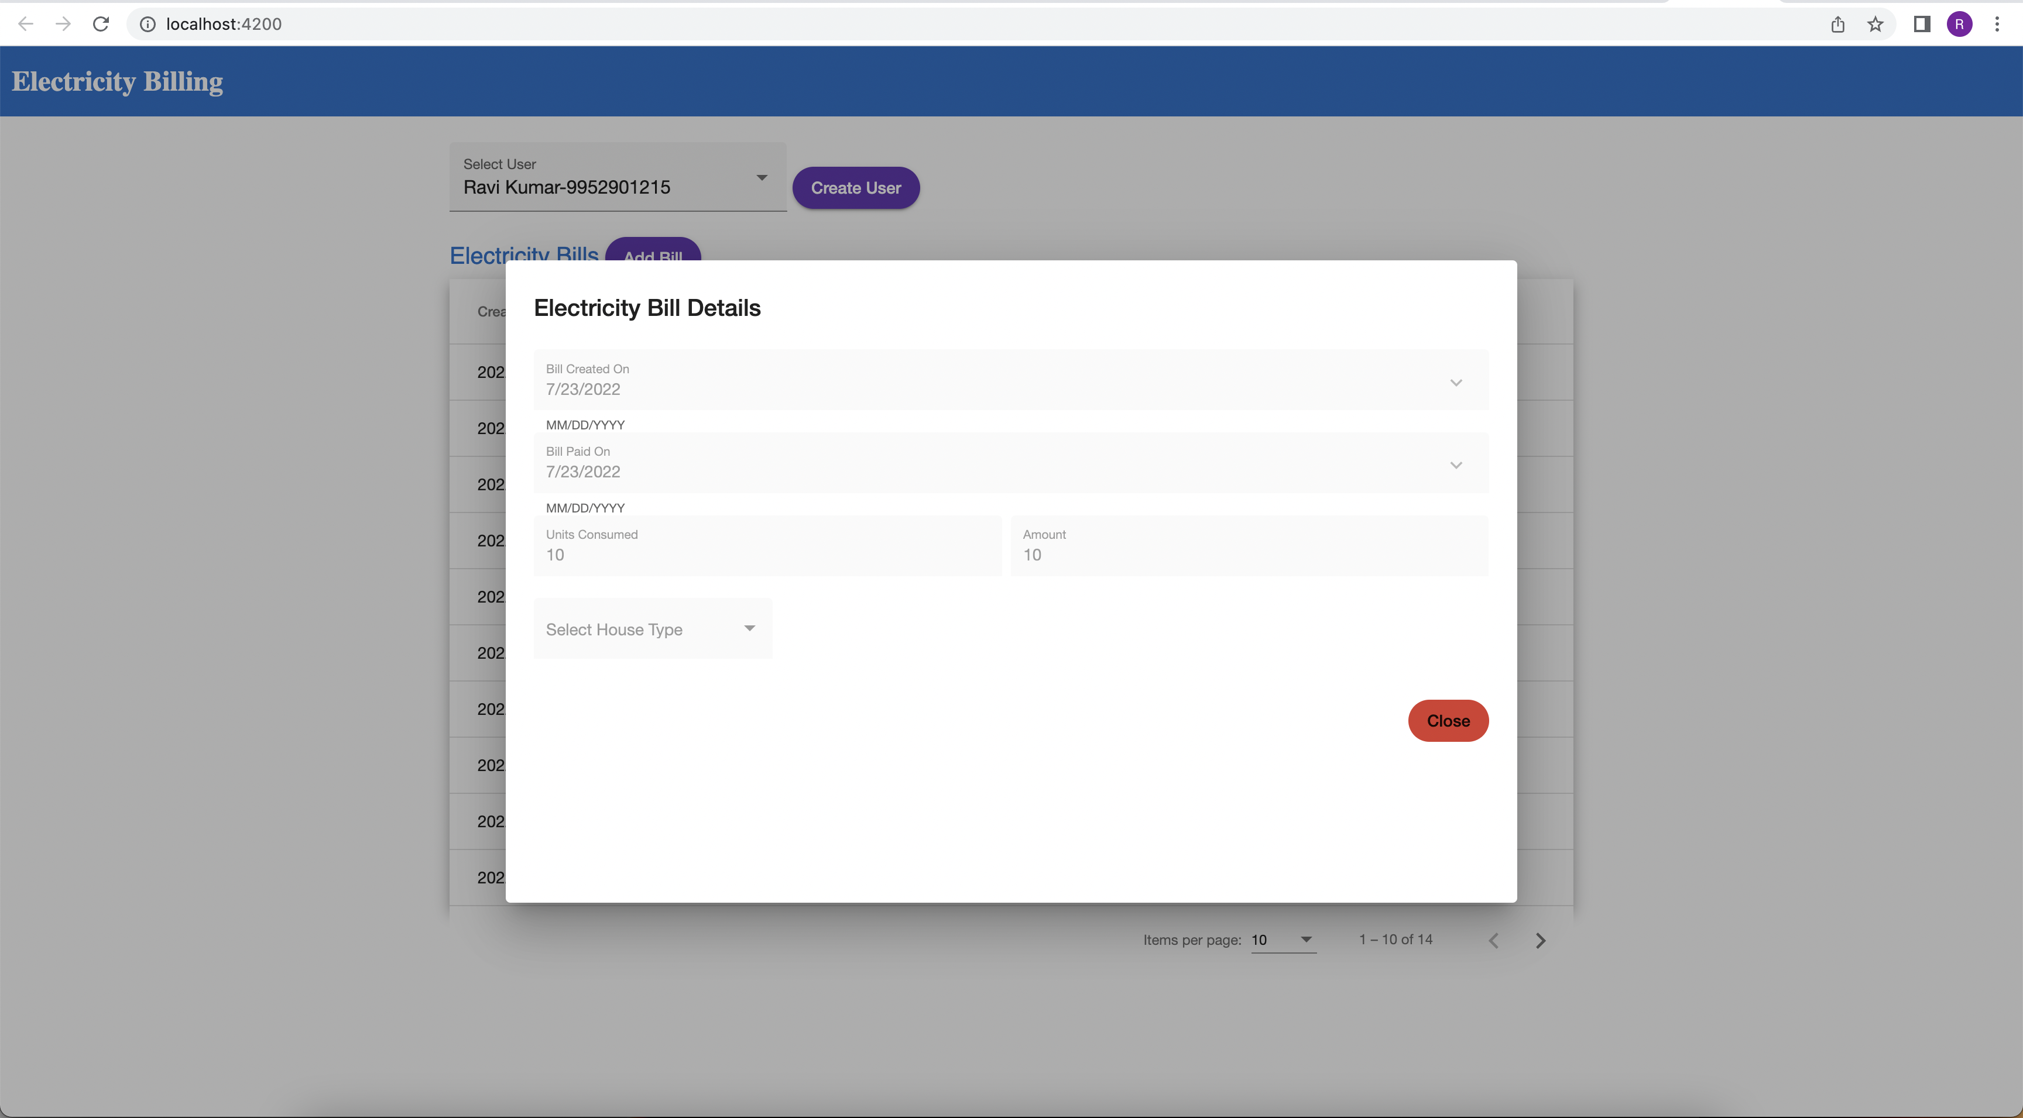*

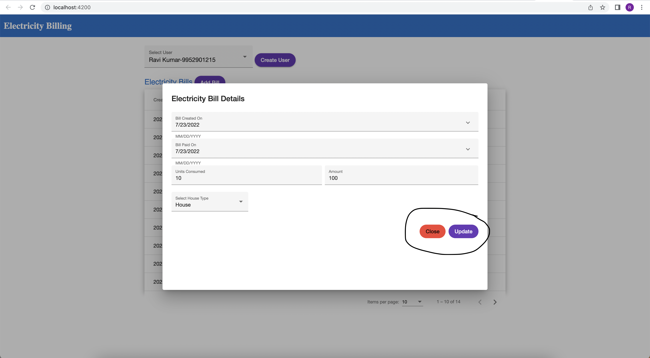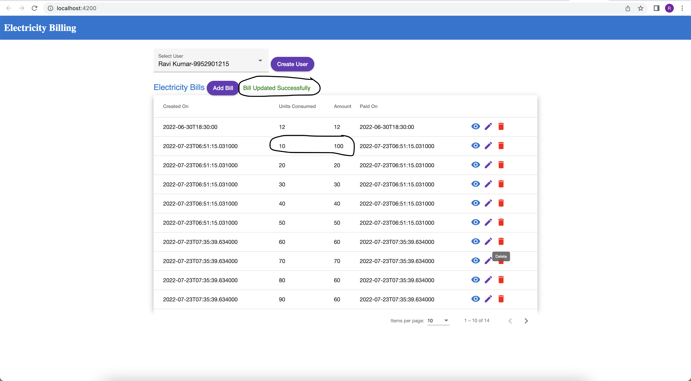

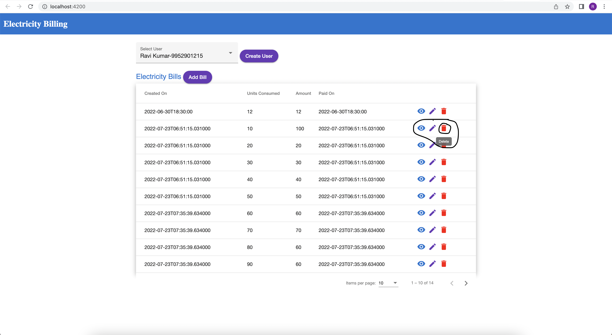

*Sort Bills - Columns wise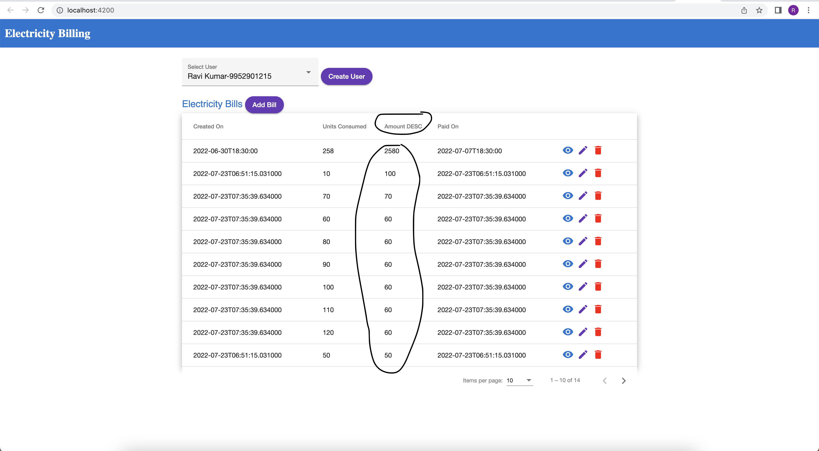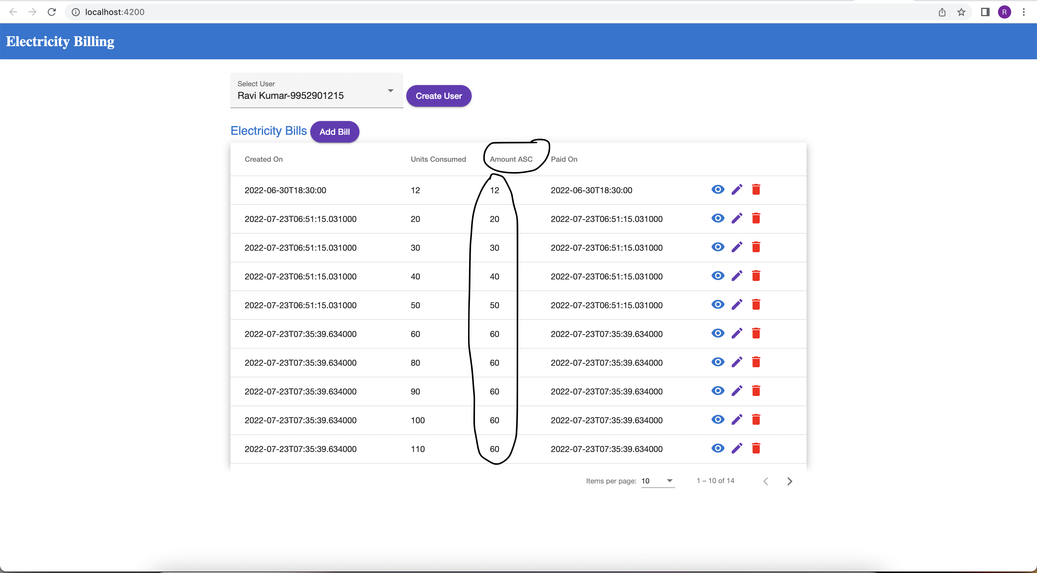*

*Pagination